**Human Emotion Detection**

**A TRAINING REPORT**

***Submitted by***

**Aditya Sharma**

**Roll no - 1815601**

***in partial fulfillment for the award of the degree***

***of***

**BACHELOR OF TECHNOLOGY**

**IN**

**COMPUTER SCIENCE AND ENGINEERING**

**AT**



**DEPARTMENT OF COMPUTER SCIENCE AND ENGINEERING**

**CGC -COLLEGE Of ENGINEERING**

**LANDRAN, MOHALI**

**JUNE 2022**



**College Of Engineering**

**Landran, Mohali**

**CANDIDATE’S DECLARATION**

I hereby certify that the work which is being presented in the report entitled “**Human Emotion Detection”** in partial fulfillment for the award of the Degree of Bachelor of Technology in Computer Science and Engineering affiliated to **Punjab Technical University, Jalandhar** and submitted to the Department of Computer Science and Engineering of College Of Engineering,Landran, is an authentic record of my own work carried out during a period from **Jan 2022 to June 2022**. The matter represented in this report has not been submitted by me for award of any other degree of this or any other institute/university.

**Date : - Name: Aditya Sharma**

**Roll no.: 1815601**

This is to certify that the above statement made by the candidate is correct to the best of our knowledge.

**Date: Training Head Head – CSE**

**PROJECT DESIGN:-**

It recognizes face and produces output by understanding face using different modules. Did you know that every time you upload a photo on facebook, the platform uses facial recognition algorithms to identify the people in that image or that certain government around the world use Facial Emotions Recognition technology around

The world uses Facial Emotions Recognition technology to identify and catch criminals. The best examples of the Facial Emotions Recognitionof you can now unlock your Smartphone using your face. The applications of this sub-domain of computer vision are vast and businesses around the world are already reaping the benefits. The usage of face recognitions models is only going to increase in the next few years.

The objective of Facial Emotions Recognition is to determine the sequence of faces units from the face so that the linguistic message in the form of text to be decoded from the scanning face .

Proposing a new combination of biometric system, gives very good feature identification accuracy compared to the existing methods. In Facial Emotions Recognition to make changes in existing system scale invariant feature extraction.

1. **real time flow diagram**

.

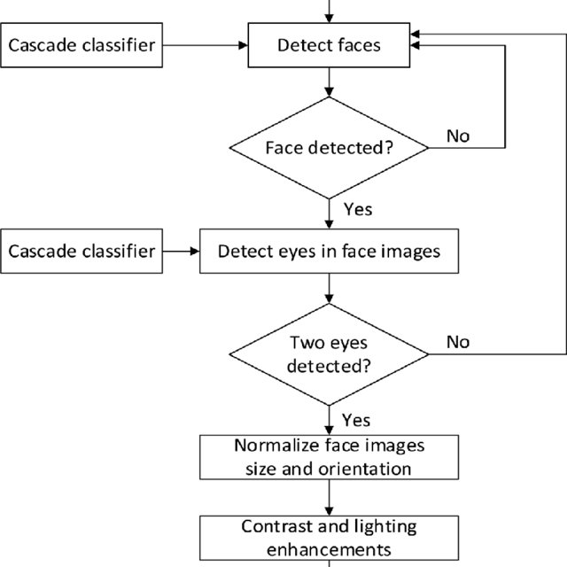

**B) Facial Emotions Recognitionsecurity system**

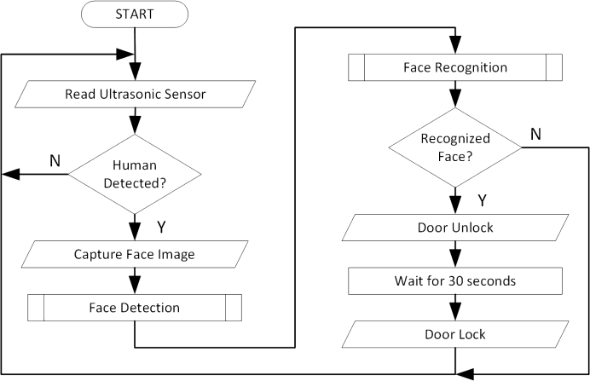

**C) Proposed recognition system**

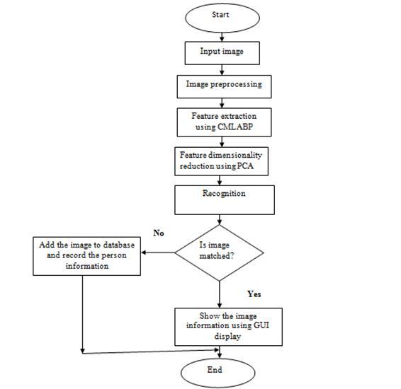

**INNOVATION IN MODEL/PROJECT:-**

We present a review on the most successful existing algorithm or methods for Facial Emotions Recognition technology to encourage researches to embark on this topic. The algorithm are principle component analysis (PCA), linear discriminant analysis(LDA), skin colour, wavelet and artificial neural network(ANN). Proposing a new combination of biometric system, gives very good feature identification accuracy compared to the existing methods. In Facial Emotions Recognition to make changes in existing system scale invariant feature extraction.

No doubt the proposed system is full GUI based that is very user friendly and all inputs to be taken all self-explanatory even to a layman. Besides, a proper training has been conducted to let know the essence of the system to the users so that they feel comfortable with new system has cut down their loads and doing. Here is flowgraph to show our new approach:-

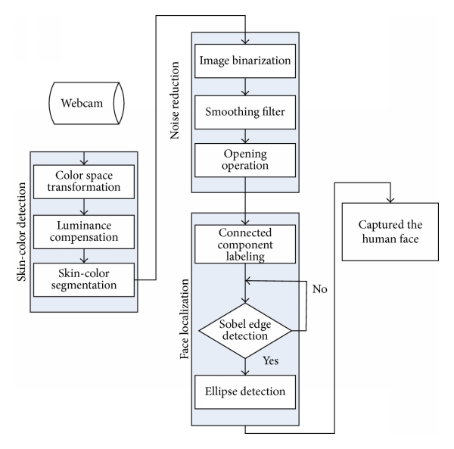

**Training and testing:-**

*Downloading the dataset*

!wget <https://www.dropbox.com/s/3uahux1uashqatp/datasets.zip?dl=0>

Unziping dataset

!unzip datasets.zip\?dl\=0

Started

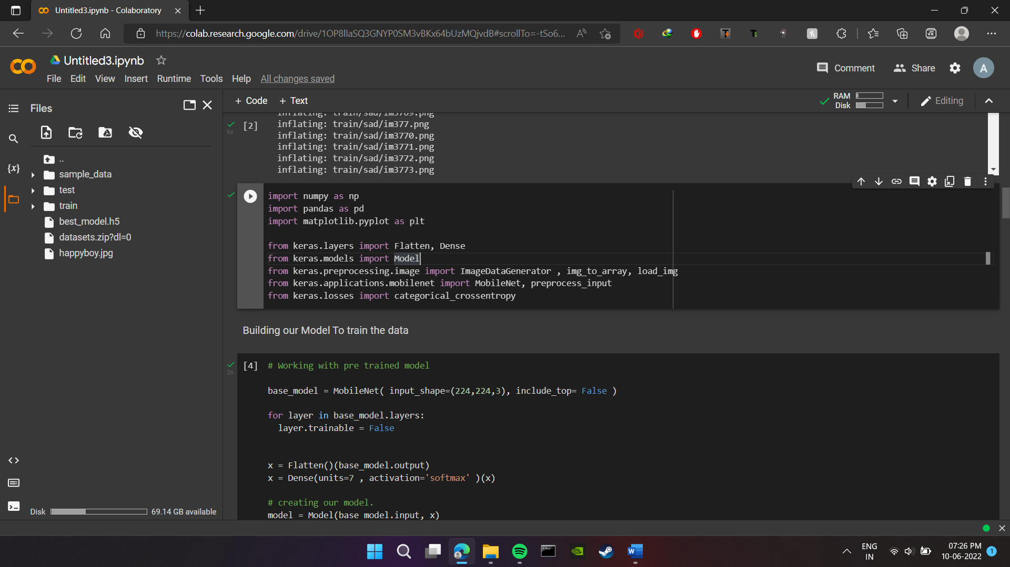

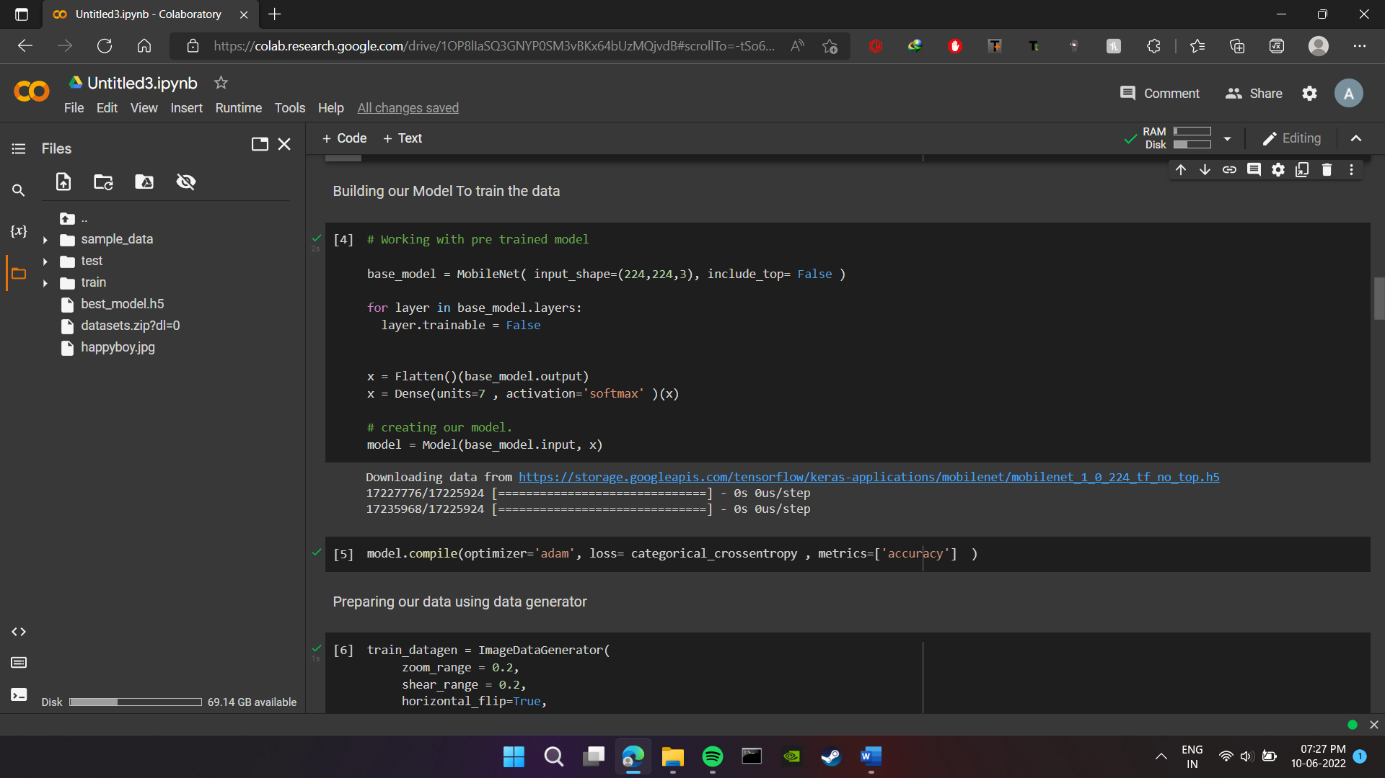

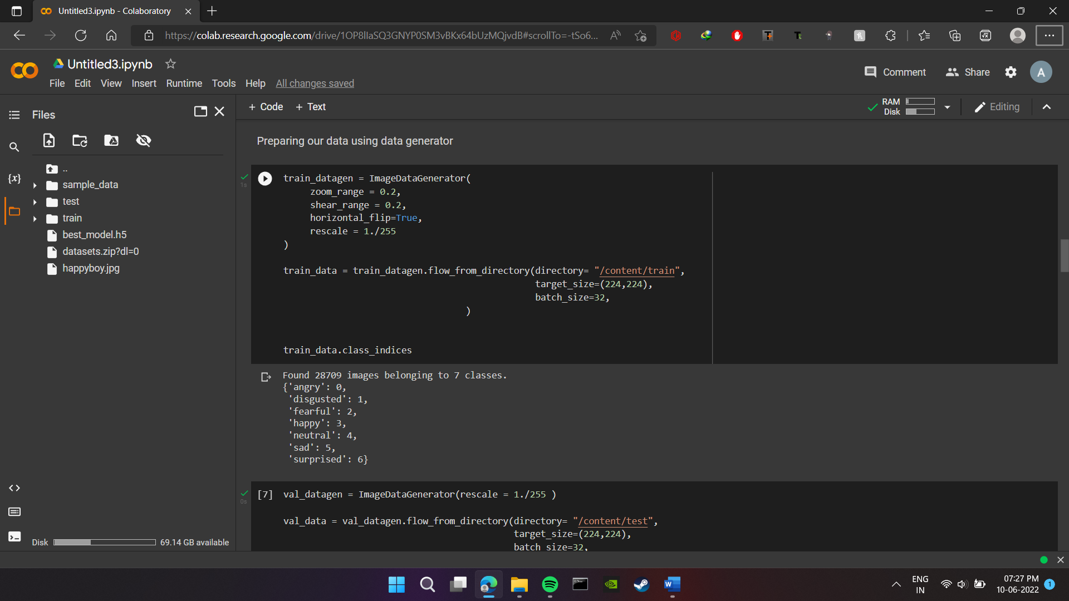

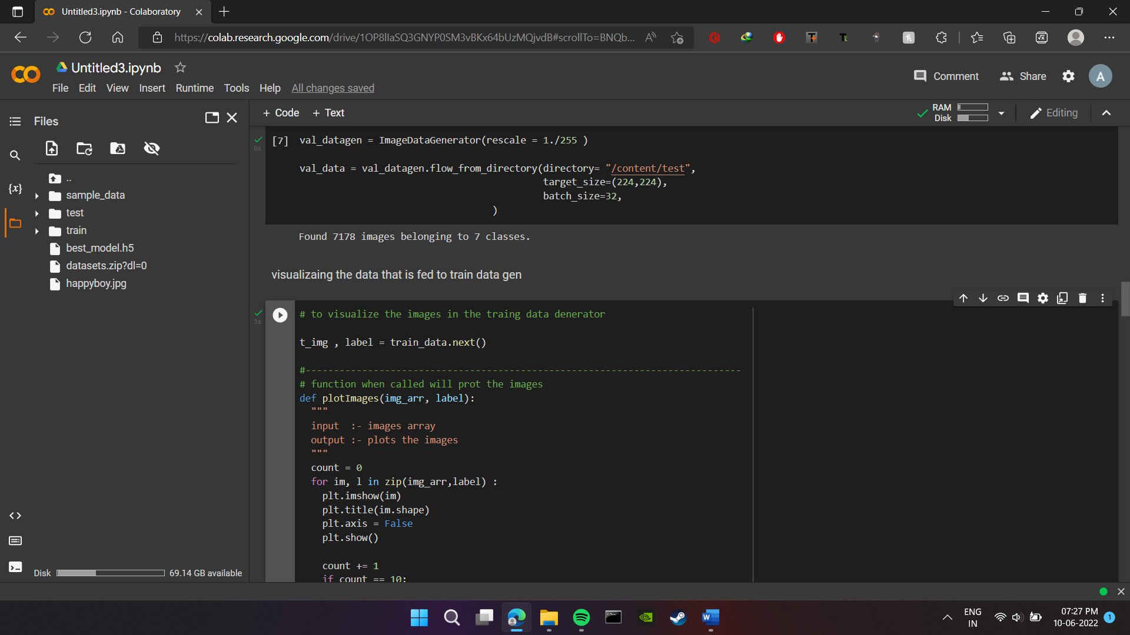

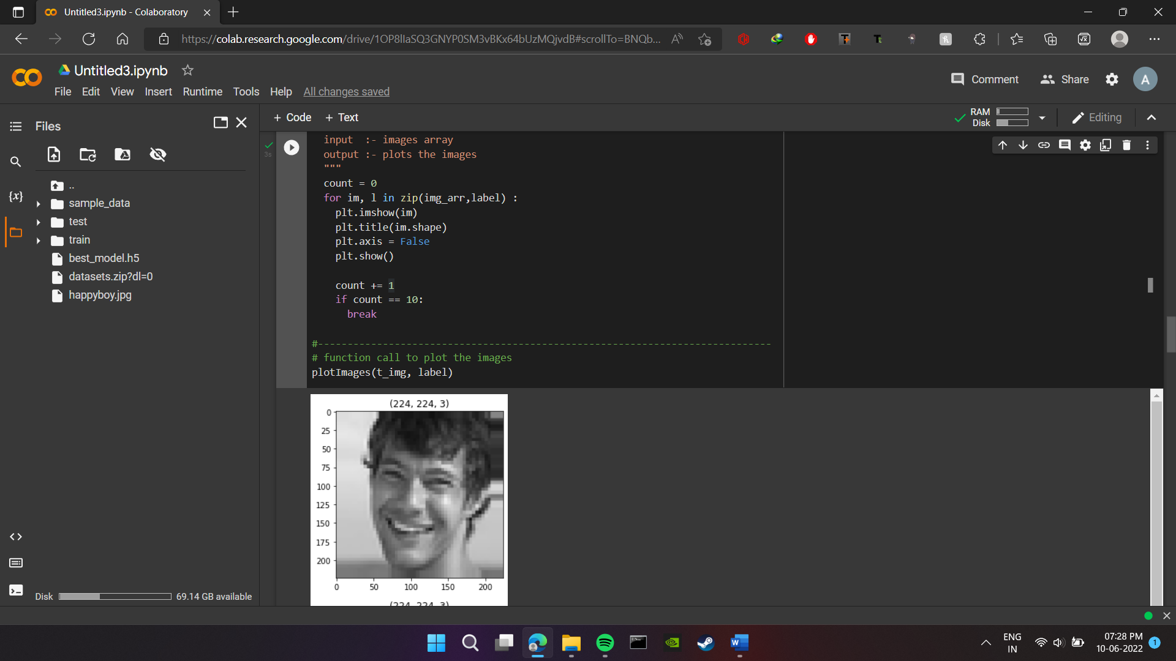

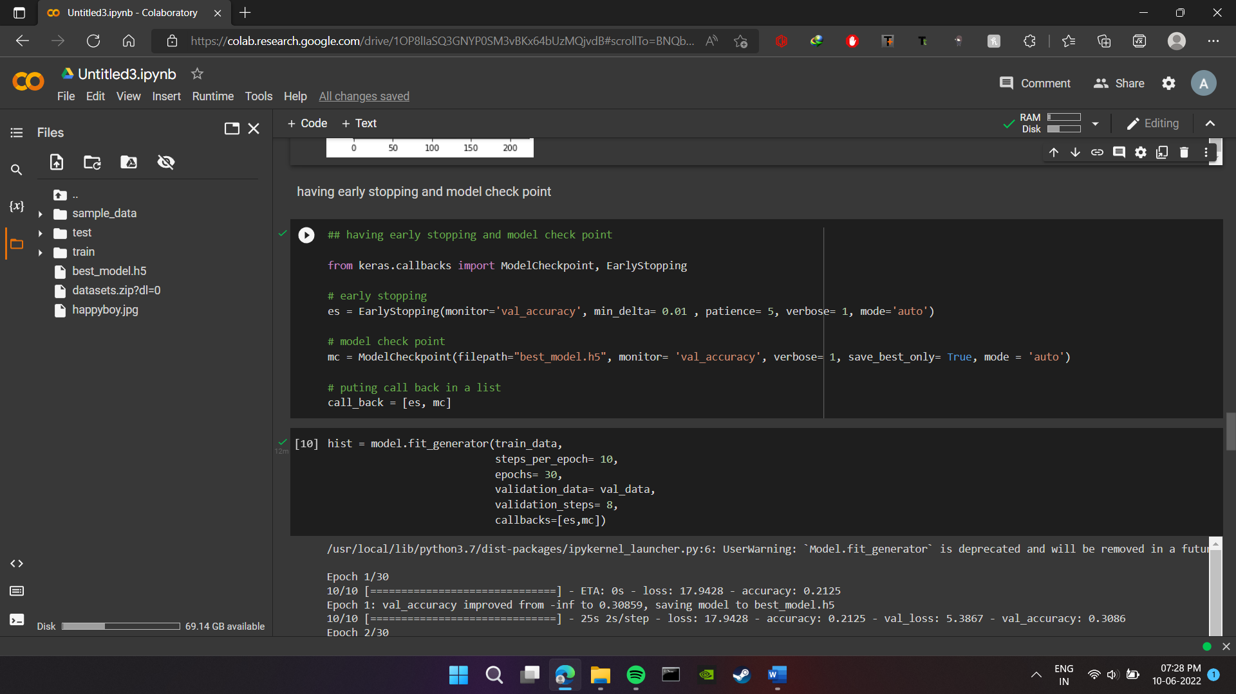

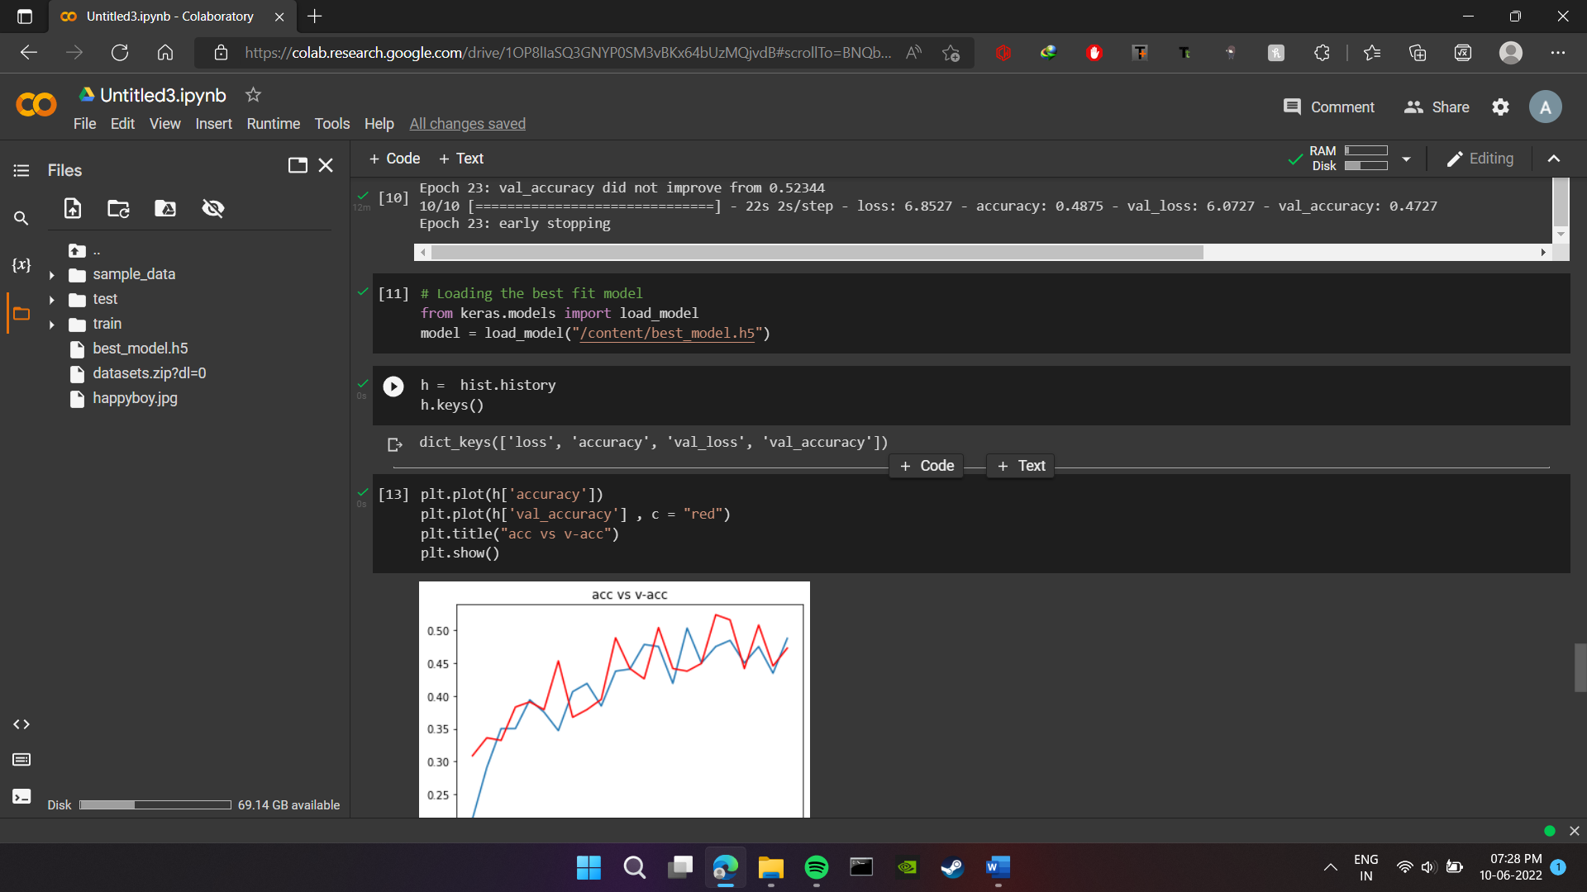

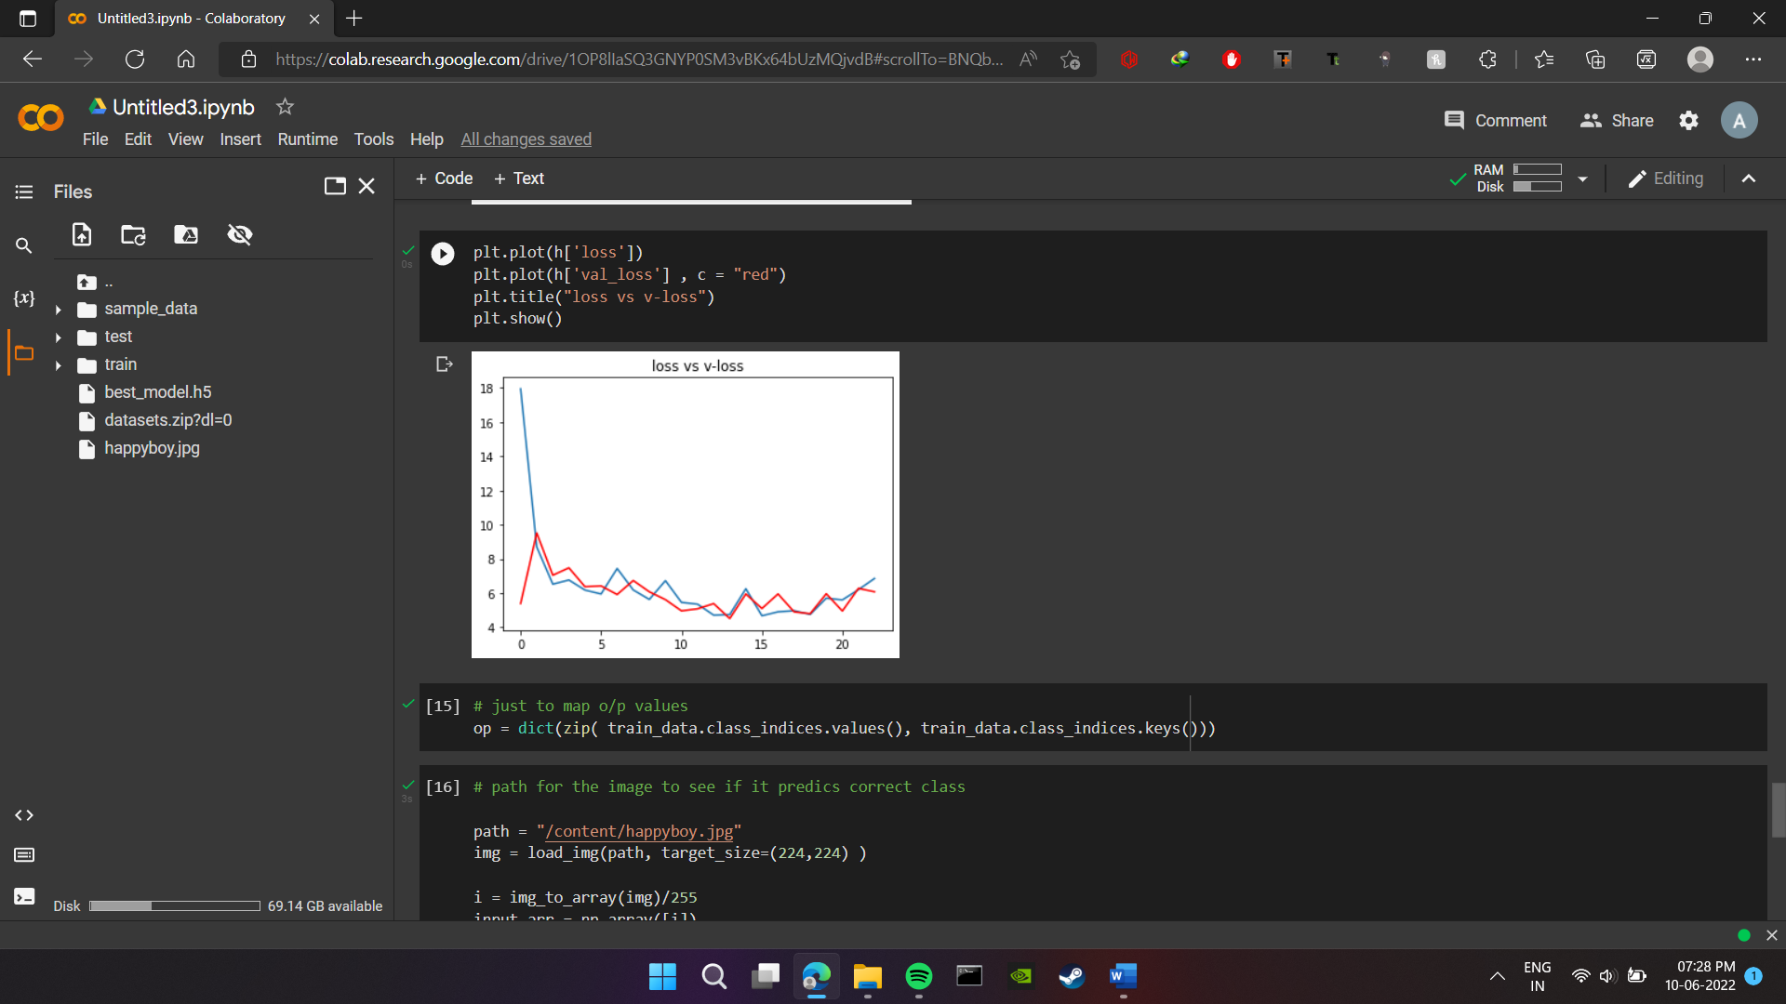

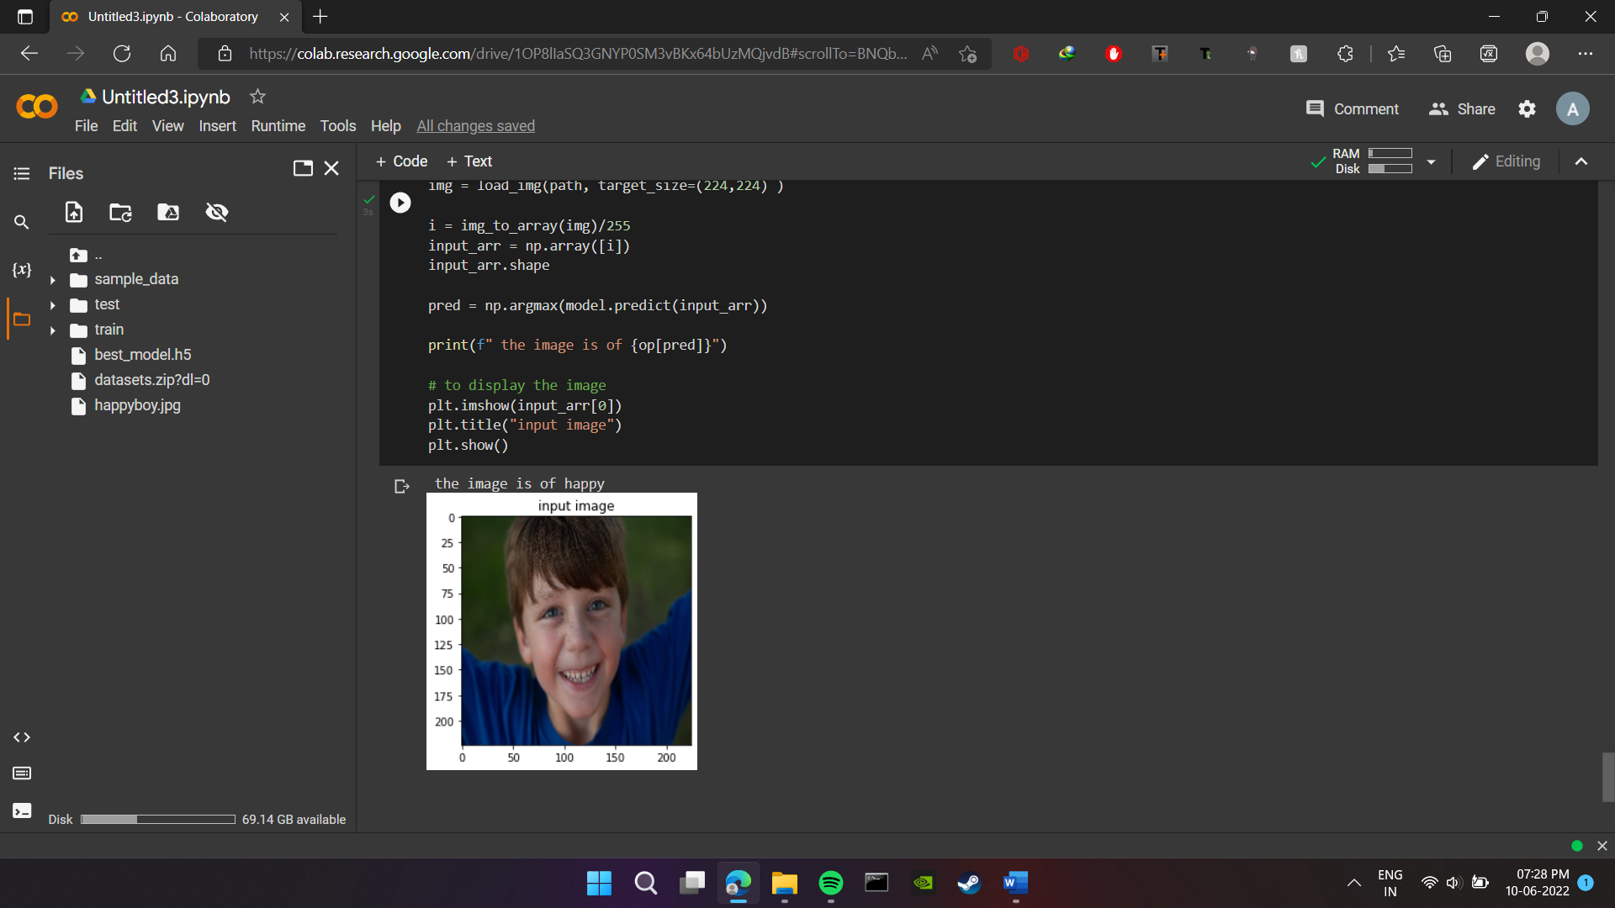

**IMPLEMENTATION:-**

**MAIN INTERFACE (CONTROL PANEL)**

**UI:**

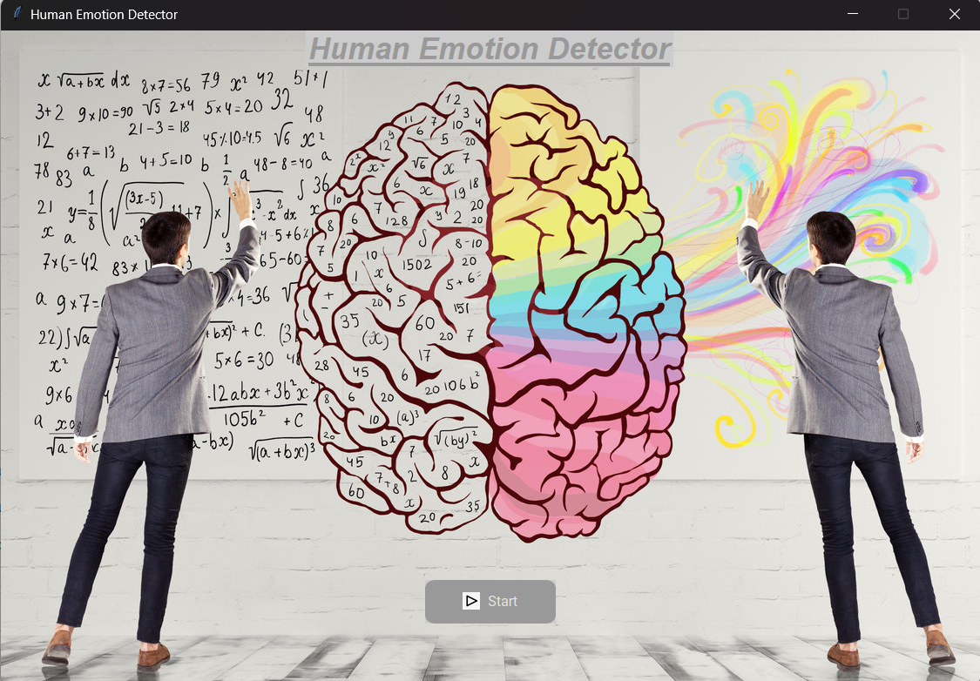

Emotion Detector:

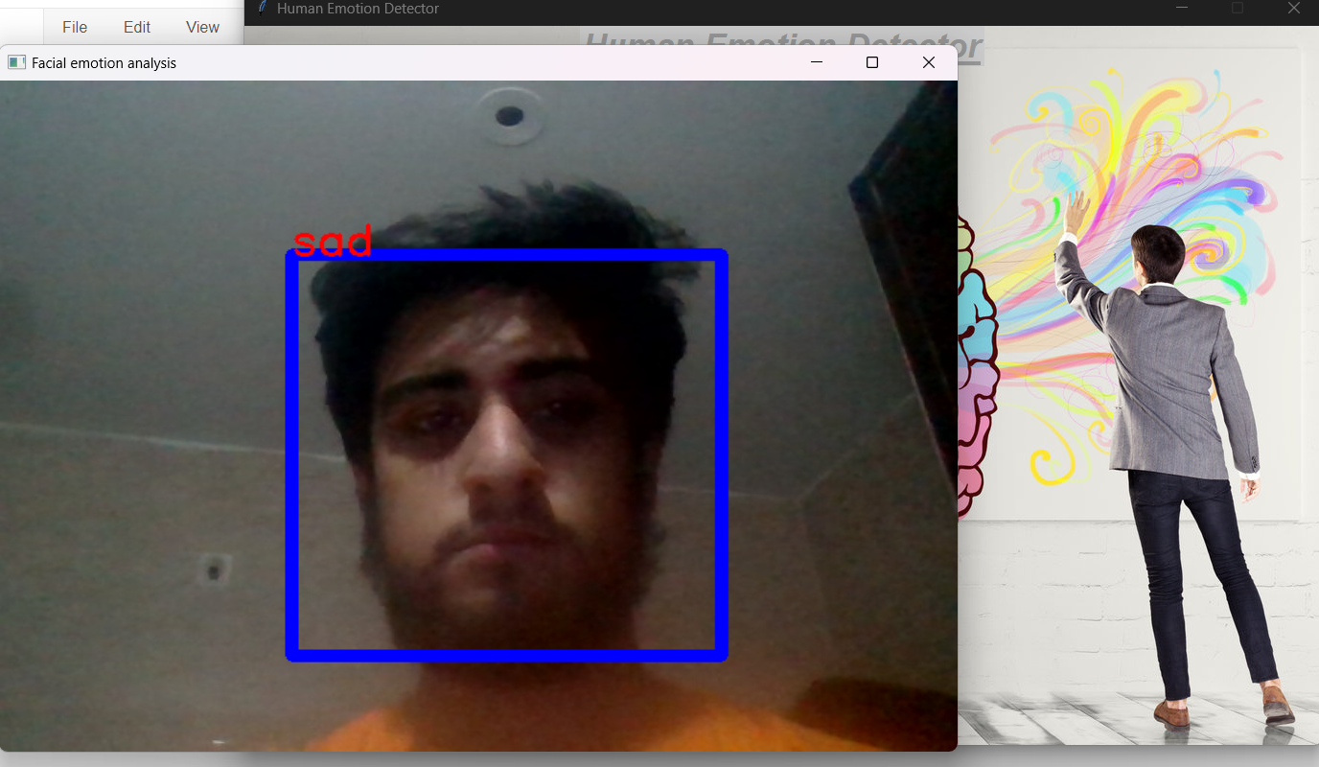

Thank You